Comparison Report
For part 1, a)
Check “gourabKoley_cm_assignment1_q1.ipynb” for the code and iterations
Newton–Raphson Method
- For the initial guess x₀ = 0, the method fails immediately since f′(0)= 0. This sensitivity of Newton’s method to derivative values, as division by zero halts the iteration.
- For x₀ = 1, the method converges successfully to the root in 5 iterations, with rapid error reduction by the fourth iteration.
- For x₀ = 0.5, convergence is slower. The algorithm initially overshoots to 1 before correcting, requiring 6 iterations to reach the root.
So, we can say that Newton–Raphson is efficient but highly dependent on the initial guess. Poor choices (like derivative zero) may lead to failure.
Muller Method
- Muller’s method uses a quadratic interpolation and requires three initial values (here taken as x₀=0, x₁=1, x₂=0.5).
- The method converges smoothly without derivative issues, reaching the root in 5 iterations.
- Although slightly slower than Newton–Raphson in terms of iteration count, Muller’s method is more robust since it does not depend directly on derivative evaluation.
So we can say that it is reliable to converge, less sensitive to bad guesses compared to Newton’s method, but more computationally intensive per iteration.
Sixth-Order Method
- For x₀ = 0, the method halts due to the derivative being zero (same limitation as Newton–Raphson).
- For x₀ = 1, it converges extremely fast: the root is found in just 3 iterations, with error reduced to machine precision.
- For x₀ = 0.5, convergence is also achieved in 3 iterations, demonstrating superior efficiency compared to Newton and Muller methods.
Thus, the sixth-order method is highly efficient when derivatives are well-defined, giving the fastest convergence. However, it shares Newton’s sensitivity to poor initial guesses (derivative zero cases).

Figure 1 Graphical Comparison for Q1 a)
Graphical Comparison (Excel Plot)
- At x₀ = 1, Newton–Raphson and Muller both required ~5 iterations, while the sixth-order method needed only 3.
- At x₀ = 0.5, Newton–Raphson required 6 iterations, Muller 5, and the sixth-order method again only 3.
- At x₀ = 0, Newton-Raphson and sixth-order methods give 0 iterations as $f^{'}\left(x\right)→0$, for x₀ = 0, and as Muller is free from derivative term and is quadratic, I have taken it as 5 iterations for all the values of initial guess x₀.
- Both Newton–Raphson and sixth-order fail at x₀ = 0 due to derivative issues, while Muller handles it smoothly.
Conclusion:
For solving f(x)=$x^{3}$−0.5=0, the sixth-order method is the most efficient when applicable, achieving convergence in the least number of iterations. However, if robustness against poor initial guesses is required, the Muller method is preferable, while Newton–Raphson lies in between — fast but sensitive.
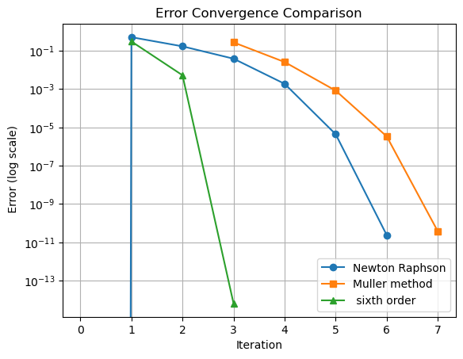
Figure 2 Error Convergence Comparison for question1 a

For part 1 b)
Check “gourabKoley_cm_assignment1_q2.ipynb” for the code and iterations
Newton–Raphson
Since it uses $x_{k+1}=x_{k}-\frac{f\left(x_{k}\right)}{f^{'}\left(x_{k}\right)}$with $f^{'}\left(x\right)=\frac{1}{x ln⁡10}-1$, so domain-wise $\log_{10}{x}$ is undefined for $x≤0$. A Large Newton step that crosses $x≤0$Reaks the iteration.
Results
- For x0 = 0.25: Jumps to −2.6637 at the first step → $\log_{10}\left(.\right)$undefined → fails (Nans thereafter).
- For x0 = 0.5: Large overshoot to 17.2335, then recovers and converges in 6 iterations to 3.550260.
- For x0 = 1: Smooth convergence in 5 iterations to 3.550260.
Hence, we can say that it is fast when started reasonably near the root and within the domain, but very sensitive to the initial guess; small positive starts can still jump negative and fail.
Muller Method
As it uses, Quadratic interpolation using three points (x0, x1, x2) = (0.25,0.5,1); it does not require derivatives and can step in the complex plane
Results
Sequence: 0.25,0.5,1 → 2.1572 → 3.2006 →3.5341 → 3.550215 → 3.550260.
It converges in 6 iterations.
Thus, we can say that it is most robust here—handled the risky small starting values without stepping out of the domain, though each iteration is a bit heavier than Newton.
Sixth-Order Method
As it is a high-order derivative-based scheme (order 6). Like Newton, it uses derivatives and can suffer if a step leaves the domain.
Results
- For x0 = 0.25: fails (Nans) after stepping out of the domain.
- For x0 = 0.5: fails similarly (Nans).
- For x0 = 1: it converges in 3 iterations to machine precision.
Thus, we can say that it is fastest when started safely, but least forgiving to risky initial guesses (shares Newton’s domain sensitivity, amplified by aggressive steps).

Figure 3 Graphical Comparison for Q1 b
Graphical Comparison (Excel plot)
- At x0 = 0.5: Newton takes 6, Muller 6, Sixth-order 3 iterations.
- At x0 = 1: Newton 5, Muller 6, Sixth-order 3.
- At x0 = 0.25: Newton and Sixth-order fail; Muller 6 iterations to converge.
Conclusion
When the starting value x0​ is too small (like 0.25), Newton’s method and the Sixth-order method fail because they take a very large first step that pushes the solution into a negative region, where $\log_{10}{x}$ is not defined. The Muller method avoids this problem and keeps the next guesses positive, so it always converges.
- Sixth-order method: Fastest (only 3 steps) if we start from a safe value near the root.
- Muller method: Most reliable, works even with poor starting guesses.
- Newton’s method: Works fine with a good guess (like x0=1), but can fail with bad ones.
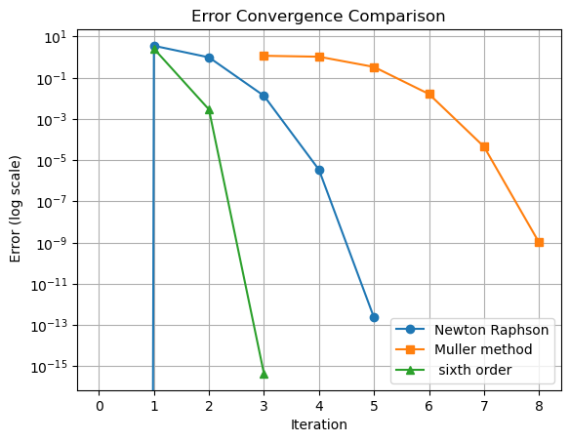
Figure 4 Error Convergence Comparison for question 1 b
FOR THE OVERALL COMPARISON
If the initial guess is uncertain or risky, Muller’s method is the safest choice. If we already know a good starting point, the Sixth-order method is the best for speed. Newton’s method lies in between.

